**Theory questions. Answer all questions**

|  |
| --- |
| ***US115368: Apply advanced HTML and associated techniques to build a web site for business applications*** |

1. Describe any five (5) design principles to keep in mind when

designing a website to ensure customers are interested and

satisfied. (5) (*SO1 AC1,2)*

*………………………………………………………………………………………………………………………………………………………………………………………………………………………………………………………………………………………………………………………………………………………………………………………………………………………………………………………………………………………………………………………………………………………………………………………………………………………………………………………………………………………………………………………………………………………………………………………………………………………………………………………………………………………………………………………………………………………………………………………………………………………………………………………………………………………………………………………………………………………………………………………………………………………………………………………………………………………………………………………………………………………………………*

1. Provide the definitions of the following two technologies: HTML and

CSS. (5) *(SO1, AC3)*

………………………………………………………………………………………………………………………………………………………………………………………………………………………………………………………………………………………………………………………………………………………………………………………………………………………………………………………………………………………………………………………………………………………………………………………………………………………………………………………………………………………………………………………………………………………………………………………………………………………………………………………………………………………………………………………………………………………………………………………………

1. Provide a description for the following HTML structure elements:

<header>, <section>, <body>. (5) *(SO1, AC2)*

…………………………………………………………………………………………………………………….

………………………………………………………………………………………………………………………………………………………………………………………………………………………………………………………………………………………………………………………………………………………………………………………………………………………………………………………………………………………………………………………………………………………………………………………………………………………………………………………………………………………………………………………………………………………………………………………………………………………………………………………………………………………………………………………………………………………………………………………………

1. Text formatting is one technique for improving the readability of

HTML text. Describe any five text formatting tags. (5)*(SO1, AC2)*

………………………………………………………………………………………………………………………………………………………………………………………………………………………………………………………………………………………………………………………………………………………………………………………………………………………………………………………………………………………………………………………………………………………………………………………………………………………………………………………………………………………………………………………………………………………………………………………………………………………………………………………………………………………………………………………………………………………………………………………………

1. In HTML, lists are used to list items using bullets, numbers or

indents. How would you differentiate between the three lists of

HTML? (5) *(SO1, AC1)*

………………………………………………………………………………………………………………………………………………………………………………………………………………………………………………………………………………………………………………………………………………………………………………………………………………………………………………………………………………………………………………………………………………………………………………………………………………………………………………………………………………………………………………………………………………………………………………………………………………………………………………………………………………………………………………………………………………………………………………………………

1. CSS3 offers three types of style sheets for formatting web content.

How would you describe these style sheets? (10)*(SO1, AC3)*

………………………………………………………………………………………………………………………………………………………………………………………………………………………………………………………………………………………………………………………………………………………………………………………………………………………………………………………………………………………………………………………………………………………………………………………………………………………………………………………………………………………………………………………………………………………………………………………………………………………………………………………………………………………………………………………………………………………………………………………………

|  |
| --- |
| **115374: Demonstrate an understanding of the use of web-**  **sites business** |

7 List 5 uses of the Internet as business tool (5) *(SO1, AC2)*

………………………………………………………………………………………………………………………………………………………………………………………………………………………………………………………………………………………………………………………………………………………………………………………………………………………………………………………………………………………………………………………………………………………………………………………………………………………………………………………………………………………………………………………………………………………………………………………………………………………………………………………………………………………………………………………………………………………………………………………………

8 Explain the techniques used to make a web site accessible and

popular (5) *(SO2, AC2)*

………………………………………………………………………………………………………………………………………………………………………………………………………………………………………………………………………………………………………………………………………………………………………………………………………………………………………………………………………………………………………………………………………………………………………………………………………………………………………………………………………………………………………………………………………………………………………………………………………………………………………………………………………………………………………………………………………………………………………………………………

9 Discuss the use of web sites in business(5) *(SO1, AC1,2)* ………………………………………………………………………………………………………………………………………………………………………………………………………………………………………………………………………………………………………………………………………………………………………………………………………………………………………………………………………………………………………………………………………………………………………………………………………………………………………………………………………………………………………………………………………………………………………………………………………………………………………………………………………………………………………………………………………………………………………………………………

**Practical Question**

|  |
| --- |
| **115369: Design and build a web-site using simple HTML** |

Using the resources provided, come up with a page similar to the one shown below. (50 marks) *(SO1, AC1,2: SO2, AC2)*

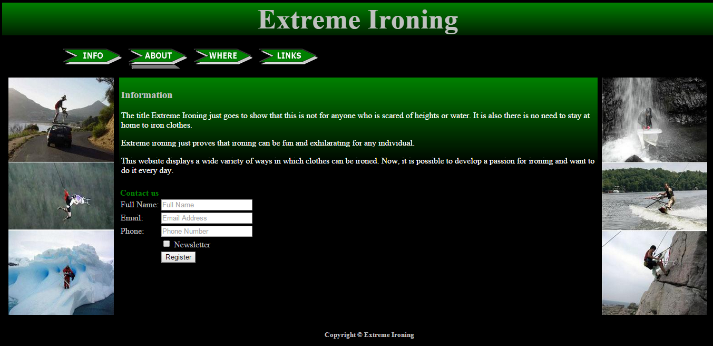

**Index.html**